
EVALUATION OF THE QUESTION PAPERS (PER PAPER)
AND
QUALITATIVE ANALYSIS OF LEARNER RESPONSES

NATIONAL SENIOR CERTIFICATE 2022

WESTERN CAPE EDUCATION DEPARTMENT

SUBJECT | ECONOMICS
PAPER | 2
DURATION OF PAPER | 2 HOURS
INTERNAL MODERATOR | MALCOLOM BLANCHARD
CHIEF MARKER | MARIAM ABDURAHMAN
DATES OF MARKING | FROM: 8 DECEMBER 2022 TO: 21 DECEMBER 2022
HEAD OF EXAMINATION | MR B LORISTON

REPORT 2: QUALITATIVE ANALYSIS OF LEARNER RESPONSES

SECTION 1: (GENERAL OVERVIEW OF LEARNER PERFORMANCE IN THE QUESTION PAPER AS A WHOLE)

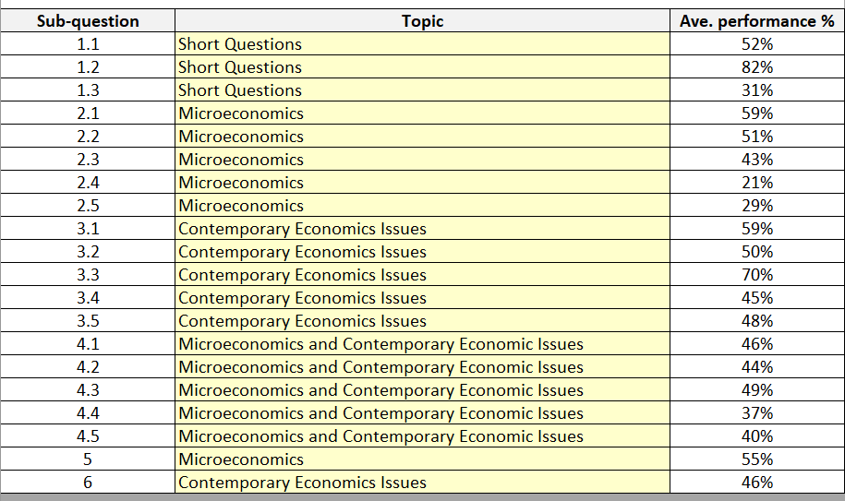
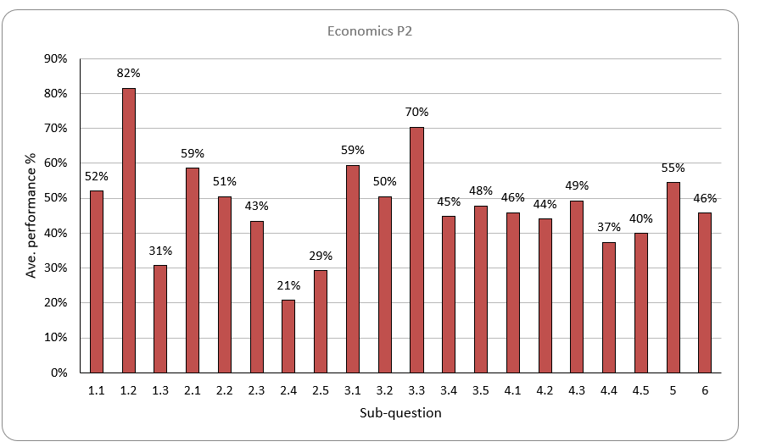
SECTION 2: COMMENT ON CANDIDATES’ PERFORMANCE IN INDIVIDUAL QUESTIONS
(It is expected that a comment will be provided for each question)

QUESTION 1
(a) General comment on the performance of learners in the specific question. Was the question well answered or poorly answered?
According to the first 100 scripts recorded (the Rasch Analysis) the average percentage is 56%.
(b) Why was the question answered poorly? Also provide specific examples, indicate common errors committed by learners in this question, and any misconceptions.
Lack of understanding of basic terminology.
(c) Provide suggestions for improvement in relation to Teaching and Learning.
Teachers must spend enough time on basic concepts and terminology. We also recommend that concept testing is done on a regular basis.
(d) Describe any other specific observations relating to responses of learners and comments that are useful to teachers, subject advisors, teacher development etc.
Try to engage learners with terminology games, such as Kahoot, Quizziz, Quizlet, Formative.

QUESTION 2
(a) General comment on the performance of learners in the specific question. Was the question well answered or poorly answered?
According to the first 100 scripts recorded (the Rasch Analysis) the average percentage is 15%.
(b) Why was the question answered poorly? Also provide specific examples, indicate common errors committed by learners in this question, and any misconceptions.
2.1 Only strong centres could answer this question. Many could not give adequate answers for 2.1.2. 2.1 Only strong centres could answer this question. Many could not give adequate answers for 2.1.2.
2.2.3: Many learners were unable to describe the term patent.
2.2.4 Most could answer this correctly.
2.2.5 Learners answered it from the consumers’ point of view. Poorly answered. In some cases, it was ‘half-answered’ – learners did not elaborate on how it benefits producers.
2.3.1 Some learners could not identify the market price. Poor interpretation.
2.3.2 Generally good.
2.3.3 Learners could not describe a minimum price, some described a maximum price.
2.3.5 Learners could not explain it and confused it with a minimum price.
2.4 Learners had substantial difficulties interpreting and explaining the graph. Learners spoke in general terms and did not make the connection with the effect of the externalities.
2.5 Poorly answered. Candidates often described characteristics of oligopolies and did not make the connection with mutual dependence.
(c) Provide suggestions for improvement in relation to Teaching and Learning.
It is evident that educators need training in the teaching of the graphs in microeconomics. Deeper teaching and learning of microeconomics is necessary. E.g. Candidates know that the perfect competitor is a price-taker, but do not know the reason. Educators must spend more time focusing on terminology.
(d) Describe any other specific observations relating to responses of learners and comments that are useful to teachers, subject advisors, teacher development etc.
The correct teaching and practicing of the drawing of graphs should be emphasized from Grades 10 and 11, and revision of graphs should be done regularly. Learners must be given the opportunity to draw and label the graphs as classroom activities.

QUESTION 3
(a) General comment on the performance of learners in the specific question. Was the question well answered or poorly answered?
According to the first 100 scripts recorded (the Rasch Analysis) the average percentage is 45%.
3.1.1 Many learners mentioned different types of inflation instead of consumer inflation.
3.2.1 Learners could not identify that when index = 100, it is the base year.
3.2.2 Many learners wrote SARS instead of SARB.
3.2.3 Many learners copied the term from Q1.3.5.
3.2.4 Many could not explain the importance of measuring inflation.
3.2.5 Many could not do the calculation.
3.3: Many candidates confused tourism with migration.
3.4. Candidates confused reasons for increase in tourism with the benefits of tourism.
3.5 Many candidates had difficulty with the higher order question. In this question, some interpreted the word ‘oil’ to be cooking oil as opposed to crude oil.
(b) Why was the question answered poorly? Also provide specific examples, indicate common errors committed by learners in this question, and any misconceptions.
See comments above.
(c) Provide suggestions for improvement in relation to Teaching and Learning.
Learners must have more practice with calculations in Economics, especially those involving a percentage change in variables/ values.
Teachers should integrate Economic events and issues into the delivery and explanation of content on a regular basis.
(d) Describe any other specific observations relating to responses of learners and comments that are useful to teachers, subject advisors, teacher development etc.
Learners seem to have significant difficulties in interpreting graph questions. The didactic approach to teaching graphs must be adapted.

QUESTION 4
(a) General comment on the performance of learners in the specific question. Was the question well answered or poorly answered?
Some parts of the question were well answered, others were not well answered.
(b) Why was the question answered poorly? Also provide specific examples, indicate common errors committed by learners in this question, and any misconceptions.
According to the first 100 scripts recorded (the Rasch Analysis) the average percentage is 35%.
4.1.1 Examples of merit goods – candidates referred to public goods in general.
4.1.2 Half answered – candidates mentioned that lower interest rates would result in more household income and spending, but did not go so far as to say that it would lead to an increase in inflation.
4.2.2 Nature of the product – candidates tended to give examples of the product, rather than describing it.
4.2.3 Many candidates could not adequately describe a natural monopoly. They simply explained a monopoly or referred to a monopoly that supplies natural resources.
4.2.4 Most candidates simply said ‘because the are the only seller’ and did not elaborate.
4.2.5 Many candidates did not show all the calculations. They must show the Rand sign and the minus sign and should show that it is TR – TC or AR – AC.
4.3.1 Most answered it correctly (wages)
4.3.2 About 50% got it right
4.3.3 Generally adequately described.
4.3.4 Most candidates explained the effect of inflation on consumers.
4.3.5 Very few candidates got the right answer. Very few could adequately explain how fiscal policy could be used to dampen inflation. Many referred to monetary policy (interest rates).
4.4 Learners gave very general answers on market failures, described market failure but not did not link their answers to the causes of market failure that was asked in the exam paper. Candidates also referred to the factors of production. Answers were mixed up as well, not clearly set out.
4.5 Adequate responses in many cases, but learners did not write enough for 8 marks.
(c) Provide suggestions for improvement in relation to Teaching and Learning.
Draw the attention to the learners of the technical difference between an artificial monopoly and a natural monopoly, especially with the aid of examples. The graphic difference should also be illustrated to learners.
Many learners seem to be confused between ‘interest rate and inflation rate’ and use the terms interchangeably. Learners don’t know the difference between monetary policy and fiscal policy. The difference between ‘demand-pull’ inflation and ‘cost-push’ inflation should be emphasized, particularly with the aid of diagrams.
(d) Describe any other specific observations relating to responses of learners and comments that are useful to teachers, subject advisors, teacher development etc.
For question 4 (market failures) – educators are advised to inform learners that they should take note of the mark allocation to the questions and to set their answers out clearly to adequately answer the question’s sub-sections

QUESTION 5
(a) General comment on the performance of learners in the specific question. Was the question well answered or poorly answered?
According to the first 100 scripts recorded (the Rasch Analysis) the average percentage is 55%.
(b) Why was the question answered poorly? Also provide specific examples, indicate common errors committed by learners in this question, and any misconceptions.
Introduction part:
Generally well answered.

Main part:
Candidates from strong centres answered this question very well.
Graphs: many challenges with the drawing of the graphs. Some learners draw the cost curves without drawing the revenue curves. Candidates indicated that where the MC intersects the AC curve is the equilibrium in all cases. They also confused marginal revenue and marginal cost, resulting in incorrect labelling of the curves. Indication of economic profit was incorrect or inaccurate due to incorrect recognition of the equilibrium output level. Some candidates drew graphs for monopoly instead of for perfect competition. Many learners did not label the vertical and horizontal axis ‘Price’, ‘Quantity’, they simply wrote ‘P’ and ‘Q’ and lost marks because of this.
Explanations: In cases where the graphs were well drawn, the explanations were generally accurate. Learners tended to explain the positioning of the curves instead of the profit situation.

Additional part:
Many learners simply listed the characteristics of perfect competition.
(c) Provide suggestions for improvement in relation to Teaching and Learning.
Learners should have a graph book in which they should practice drawing graphs regularly and give regular ‘spot tests’ to keep learners skills sharp with regard to drawing and labeling graphs.
(d) Describe any other specific observations relating to responses of learners and comments that are useful to teachers, subject advisors, teacher development etc.
The importance of drawing the cost curves accurately, so that the MC curve intersects the AC curve at its minimum point, must be emphasized. If this is not done correctly, it is unlikely that candidates will be able to answer this type of question correctly.

QUESTION 6
(a) General comment on the performance of learners in the specific question. Was the question well answered or poorly answered?
According to the first 100 scripts recorded (the Rasch Analysis) the average percentage is 46%.
(b) Why was the question answered poorly? Also provide specific examples, indicate common errors committed by learners in this question, and any misconceptions.
Main part:
Learners wrote the essay that they studied instead of the essay that was asked, e.g. they wrote about the benefits of tourism.
Additional part:
On the whole, this part of the question was not well answered. Learners clearly need more exposure to the topic (environmental sustainability) through regular class discussions.
(c) Provide suggestions for improvement in relation to Teaching and Learning.
They should also be made to write the essays out regularly, including essay tests, essay competitions, etc.
(d) Describe any other specific observations relating to responses of learners and comments that are useful to teachers, subject advisors, teacher development etc.
Candidates should be advised to study all of the relevant essays for the Main Topic in each exam.
It seems as if learners tried to ‘spot’ the essay question. Some simply pressed ahead with discussing the benefits of tourism or the effects of tourism, or the other environmental essay.

