
EVALUATION OF THE QUESTION PAPERS (PER PAPER)
AND
QUALITATIVE ANALYSIS OF LEARNER RESPONSES

NATIONAL SENIOR CERTIFICATE 2022

WESTERN CAPE EDUCATION DEPARTMENT

SUBJECT | AFRIKAANS HOME LANGUAGE
PAPER | 2
DURATION OF PAPER | 2 HOURS 30 MINUTES
INTERNAL MODERATOR | IMMANUEL EUROPA
CHIEF MARKER | LAETITIA VAN HEERDEN
DATES OF MARKING | FROM: 08 DECEMBER 2022 TO: 20 DECEMBER 2022
HEAD OF EXAMINATION | MR B LORISTON

REPORT 2: QUALITATIVE ANALYSIS OF LEARNER RESPONSES

SECTION 1: (GENERAL OVERVIEW OF LEARNER PERFORMANCE IN THE QUESTION PAPER AS A WHOLE)

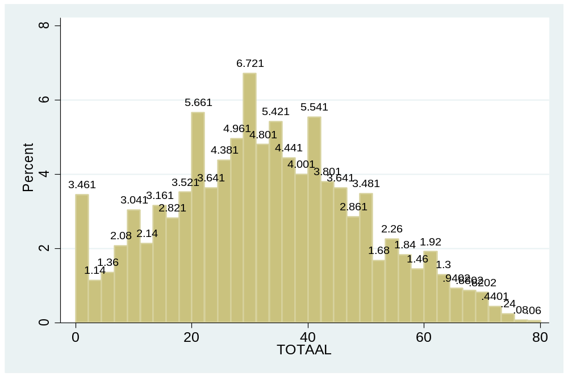
Variable | Obs Mean Std. Dev. Min Max
----------------------------------------------------------------------
TOTAAL | 4999 32.6 16.6 0 80

The candidates’ performance ranges from below average to good. Very few learners achieved full marks in this paper.
Candidates could respond to the required number of questions to be answered in Section A, B and C.
Section A: candidates showed average to under average performance.
Section B: was answered reasonably well, especially the essay type question, however, candidates struggled with the contextual questions. It trends due to lack of knowledge of the text or their lack of skill to construct or give appropriate responses to higher level questions. Candidates achieved a mix range of marks from average to good.
Section C: graph leaned to good and very good performance in essay type question with average in contextual questions.
Candidates generally achieved higher marks for essay questions than contextual questions across all genres.
Despite reasonably good performance by many, some centres reflect that candidates were not exposed to thorough teaching and learning, evident in their lack of ability to answer easy/simple questions or not able to construct an adequate answer to the essay or contextual questions. In other centres it was clear that adequate and excellent teaching and guidance was provided, hence candidates in those centres collectively achieving marks well above average to full marks.

SECTION 2: COMMENT ON CANDIDATES’ PERFORMANCE IN INDIVIDUAL QUESTIONS
(It is expected that a comment will be provided for each question)

QUESTION 1
(a) General comment on the performance of learners in the specific question. Was the question well answered or poorly answered?
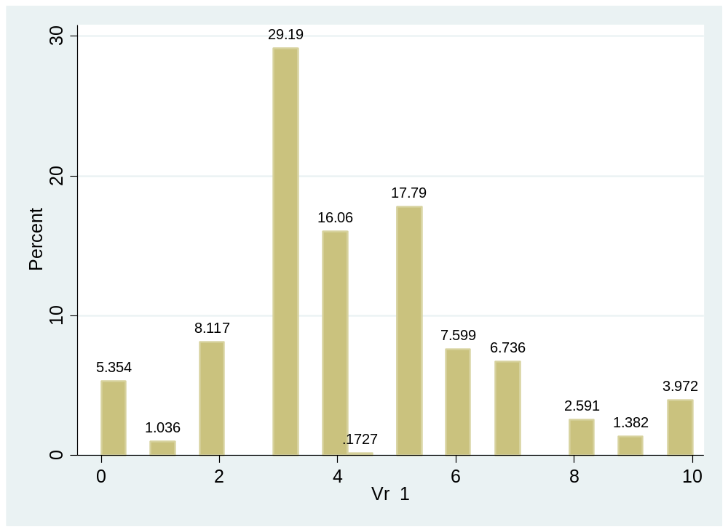
Variable | Obs Mean Std. Dev. Min Max
-------------+--------------------------------------------------------
Vr1 | 579 4.2 2.1 0 10

This question was answered from average to good.
(b) Why was the question answered poorly? Also provide specific examples, indicate common errors committed by learners in this question, and any misconceptions.
Candidates had basic knowledge of the genre and format of the essay type question. Some however lack the skill and comprehension of literary concepts, e.g. “stylfigure”, “retoriese middele” to construct a proper or good essay.
(c) Provide suggestions for improvement in relation to Teaching and Learning.
Candidates need to practice the skills and knowledge on how to analyze the question and construct only the content needed and stick to what the question requires.
Recommendation is that teachers (and learners) should use previous exam papers to teach and learn how to interpret similar question set and the appropriate respond to that question within context of the poem, with sound knowledge on theme of the poem. Most candidates fair average to above average in this question
Comprehensive teaching of essay questions on poetry continuing to:
- Promote candidates to answer the poetry essay question;
- Understanding, analysis and interpretation of the question;
Formulating the answer in essay form as prescribed by the question.
(d) Describe any other specific observations relating to responses of learners and comments that are useful to teachers, subject advisors, teacher development etc.
Suggestion of intensive teaching and revision to acquire skill to construct appropriate essay. Expose learners to all the different examples of how the question is set.

QUESTION 2
(a) General comment on the performance of learners in the specific question. Was the question well answered or poorly answered?
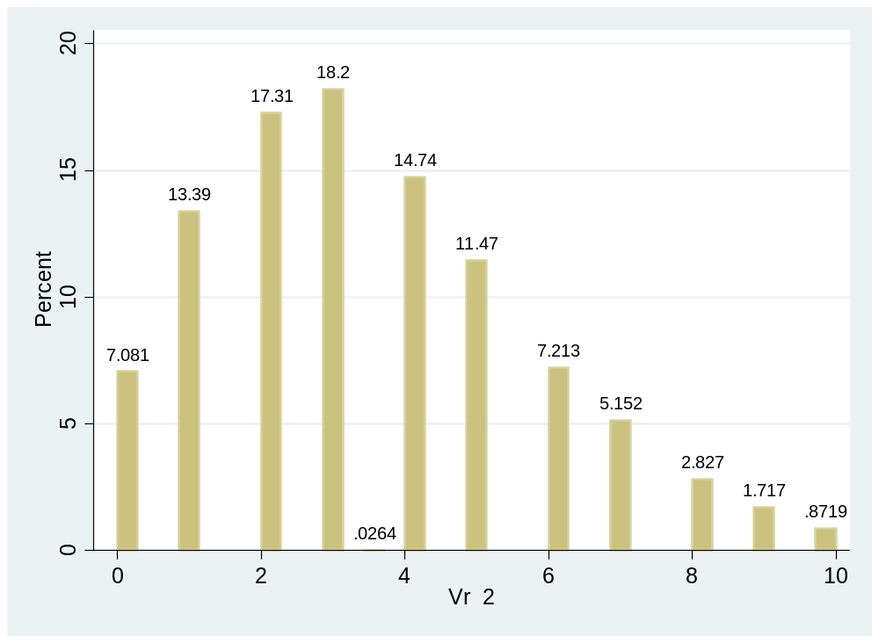
Variable | Obs Mean Std. Dev. Min Max
-------------+--------------------------------------------------------
Vr2 | 3785 3.4 2.2 0 10

Candidates showed a below average performance in this question.

(b) Why was the question answered poorly? Also provide specific examples, indicate common errors committed by learners in this question, and any misconceptions.
Candidates struggled to answer the following:
Q 2.2 “veranderde fokus”
Q 2.3 “ “kontrasteer met dié beeld”
Q 2.6 “tema van die gedig” Candidates also did not “motiveer” appropriately.
(c) Provide suggestions for improvement in relation to Teaching and Learning.
Thorough teaching of “tema”.
(d) Describe any other specific observations relating to responses of learners and comments that are useful to teachers, subject advisors, teacher development etc.
Thorough interpreting and explanation or discussions on words/terminology used within the context of the poem.

QUESTION 3
(a) General comment on the performance of learners in the specific question. Was the question well answered or poorly answered?
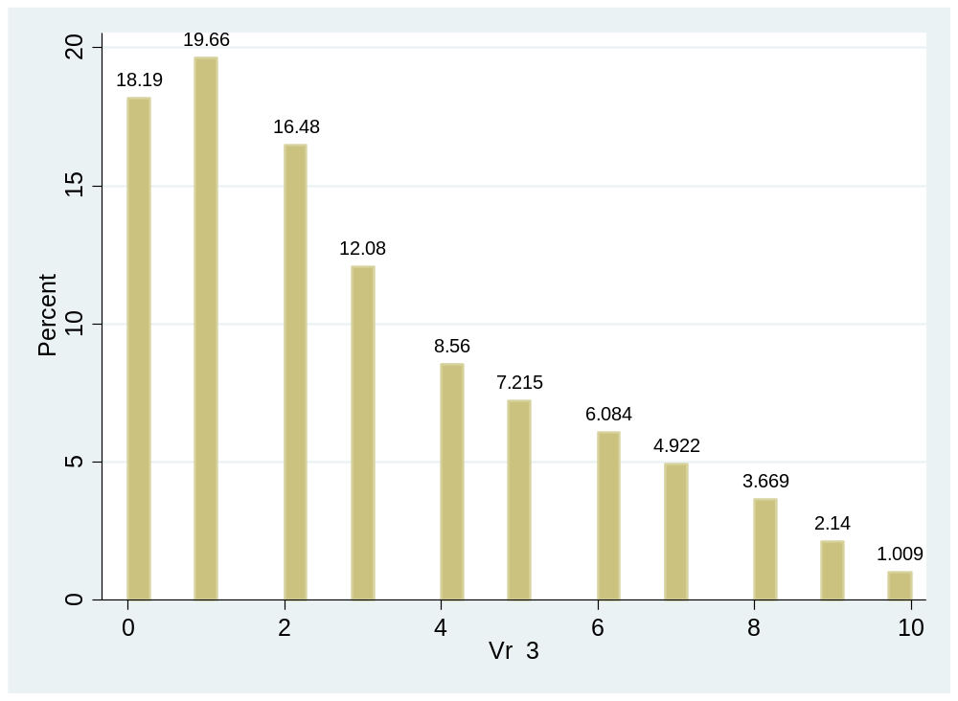
Variable | Obs Mean Std. Dev. Min Max
-------------+--------------------------------------------------------
Vr3 | 3271 2.8 2.5 0 10

Poor performance in this question.
(b) Why was the question answered poorly? Also provide specific examples, indicate common errors committed by learners in this question, and any misconceptions.
The following questions proved to be challenging:
Q 3.1 “figuurlike betekenis van titel”
Q 3.2.1 “tipografies uitgehef”
Q3.3. “enjambement funksioneel”
Q 3.4 “ironie”
Q 3.5 “herhaling van hier doeltreffend”
Q 3.6 “afwesigheid van hoofletters”
(c) Provide suggestions for improvement in relation to Teaching and Learning.
Thorough interpreting and explanation or discussions on words/terminology used within the context of the poem, e.g. “ironie, funksie van enjambement en tipografie.
(d) Describe any other specific observations relating to responses of learners and comments that are useful to teachers, subject advisors, teacher development etc.
Intensive teaching and revision.

QUESTION 4
(a) General comment on the performance of learners in the specific question. Was the question well answered or poorly answered?
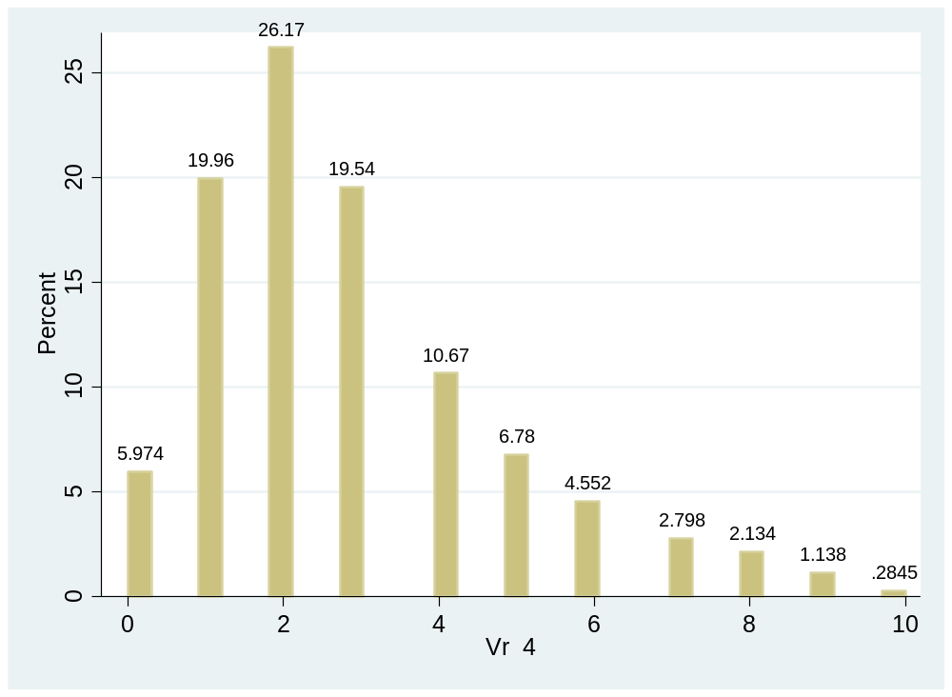
Variable | Obs Mean Std. Dev. Min Max
-------------+--------------------------------------------------------
Vr4 | 2109 2.8 1.9 0 10

Candidates performed at below average to average level.
(b) Why was the question answered poorly? Also provide specific examples, indicate common errors committed by learners in this question, and any misconceptions.
The following questions pose difficulty:
Q 4.1.2. “ander harmonie”
Q 4.4 “stemming en verbreek van stemming”
Q 4.5.2 “suggestie weerspreek”
(c) Provide suggestions for improvement in relation to Teaching and Learning.
Thorough teaching of all different terminology and words used in poems e.g. stemming.
(d) Describe any other specific observations relating to responses of learners and comments that are useful to teachers, subject advisors, teacher development etc.
Use previous exam papers for preparation.

QUESTION 5
(a) General comment on the performance of learners in the specific question. Was the question well answered or poorly answered?
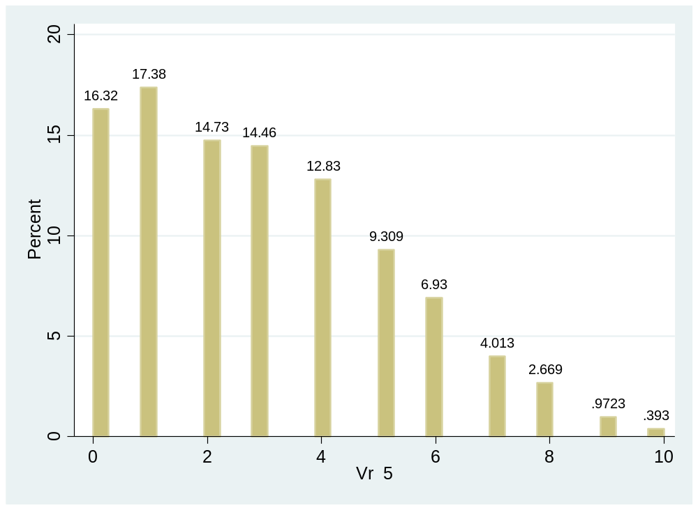
Variable | Obs Mean Std. Dev. Min Max
-------------+--------------------------------------------------------
Vr5 | 4834 2.9 2.2 0 10

Poor performance in the unseen poem in contrast to the previous year.

(b) Why was the question answered poorly? Also provide specific examples, indicate common errors committed by learners in this question, and any misconceptions.
The following questions referred:
Q 5.2. “perlemoenstroper”
Q 5.4 “waarom is die halfrym funksioneel”
Q 5.5 “geloofwaardige afleiding” and “met perlemoenstroper identifiseer”
Q 5.6 “retoriese middle”
(c) Provide suggestions for improvement in relation to Teaching and Learning.
Proper knowledge on words and terms used in poetry.
Teaching should reference prior knowledge to current events relating to content of genre/poems.
(d) Describe any other specific observations relating to responses of learners and comments that are useful to teachers, subject advisors, teacher development etc.
Teaching and revision of previous papers.

QUESTION 12
(a) General comment on the performance of learners in the specific question. Was the question well answered or poorly answered?
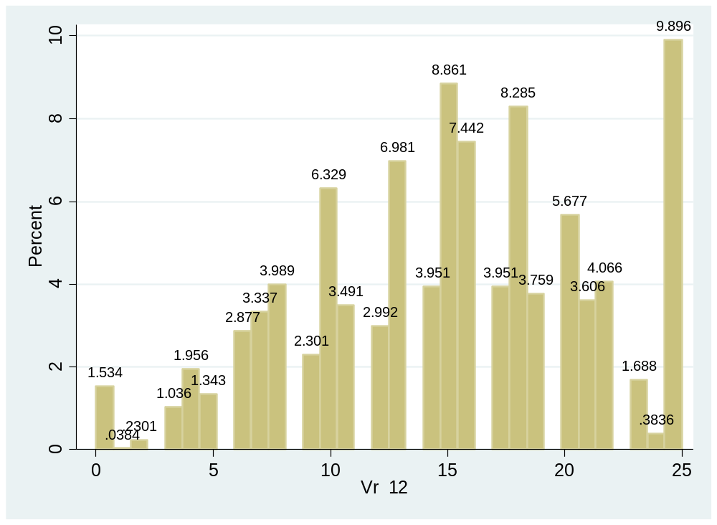
Variable | Obs Mean Std. Dev. Min Max
-------------+--------------------------------------------------------
Vr12 | 2607 15.0 6.0 0 25

This question was answered above average to good.
(b) Why was the question answered poorly? Also provide specific examples, indicate common errors committed by learners in this question, and any misconceptions.
Some candidates however struggle to focus only on Greg and thus could not construct a proper response to obtain good marks. In constructing the essay, they fail to properly connect “vals” and “invloed”.
(c) Provide suggestions for improvement in relation to Teaching and Learning.
Teaching and practice of skills to properly answer the essay question.
(d) Describe any other specific observations relating to responses of learners and comments that are useful to teachers, subject advisors, teacher development etc.
Teaching on how to write/construct a basic essay question is essential. Thorough reading, analysis and understanding of literature as well as frequent practice on how to answer an essay question effectively. Also do analysis of the text e.g. group/class discussions on different interactions between characters, etc. Important that candidates should aquire detailed content.

QUESTION 13
(a) General comment on the performance of learners in the specific question. Was the question well answered or poorly answered?
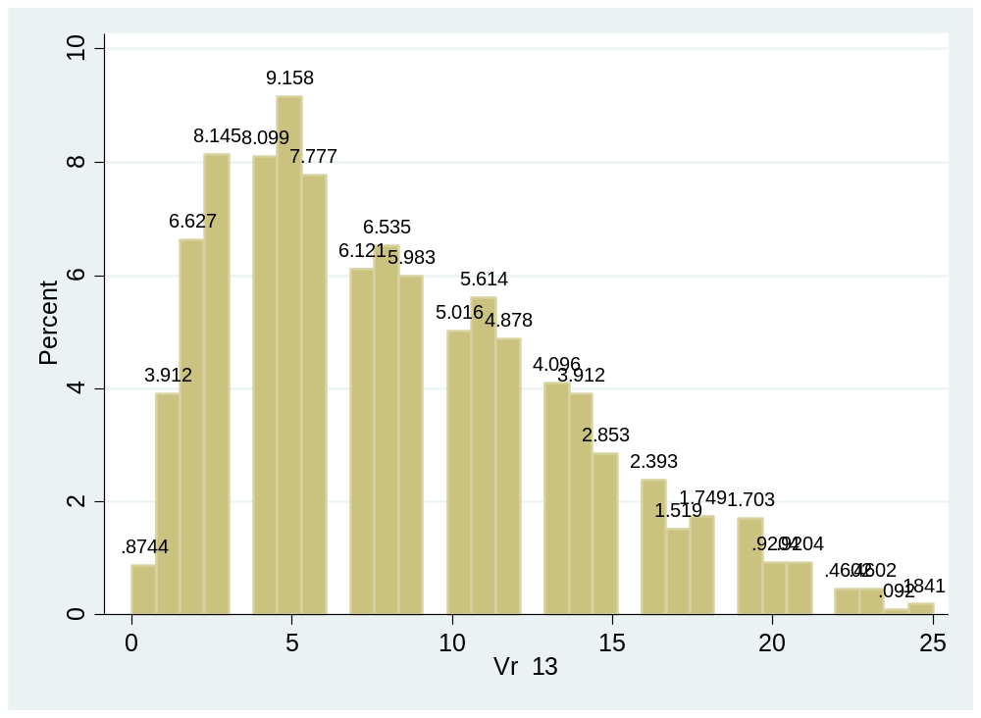
Variable | Obs Mean Std. Dev. Min Max
-------------+--------------------------------------------------------
Vr13 | 2173 8.2 5.1 0 25

Candidates had a poor performance in this question.
(b) Why was the question answered poorly? Also provide specific examples, indicate common errors committed by learners in this question, and any misconceptions.
The following questions had inappropriate answers:
Q 13.3.1 “ hoe sluit hierdie reël by die titel van die roman aan”
Q 13.3.2 “slagoffer van sy omstandighede”
Q 13.3.3 “sy pa eerste keer sien huil”
Q 13.5 “sy naam los op in die donker”
Q 13.7.1 “twee dinge vir inspekteur Cele vertel?”
Q 13.7.2 “houding teenoor Eckardt wat verander”
Q 13.9.1 “ironie”
Q 13.9.2 “inligting wat joernaliste nie weet nie”
Q 13.10 “innerlike konflik by Greg”
(c) Provide suggestions for improvement in relation to Teaching and Learning.
Very thorough knowledge of the content needed. Regular revision and class discussion is absolutely essential.
(d) Describe any other specific observations relating to responses of learners and comments that are useful to teachers, subject advisors, teacher development etc.
Candidates and teachers must read and discuss the genre/book in class! Teachers need to research and prepare for lessons; specifically, on any possible essay questions (especially within expected examination style for CAPS system). This novel is filled with exciting avenues and discussions around the plot. Another recommendation: search the Internet / Google where you can find thousands of resources on all genres or titles. Candidates are inclined to visual stimuli so it is recommended to make use of videos, PPT and all other electronic media which will improve interest first and ultimate teaching and learning.
Suggested Internet sites: WCED, Eastern Cape Education Department, DBE, Thutong, etc.

QUESTION 14
(a) General comment on the performance of learners in the specific question. Was the question well answered or poorly answered?
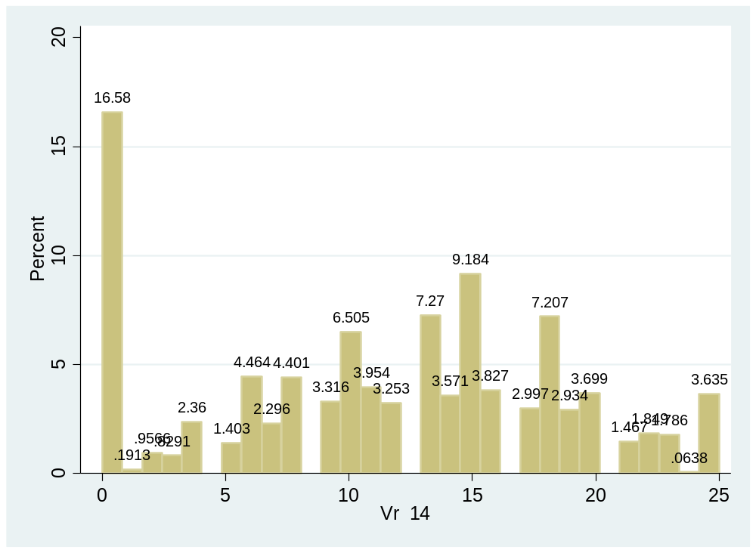
Variable | Obs Mean Std. Dev. Min Max
-------------+--------------------------------------------------------
Vr14 | 1568 11.3 7.1 0 25
Average performance in this question
(b) Why was the question answered poorly? Also provide specific examples, indicate common errors committed by learners in this question, and any misconceptions.
Candidates’ knowledge of the characters, Miss Africa and Apostel George, was not sufficient to construct a complete or detailed essay.
(c) Provide suggestions for improvement in relation to Teaching and Learning.
Further strengthening of skills in applying facts to motivate discussion points and requirements of an essay question.
(d) Describe any other specific observations relating to responses of learners and comments that are useful to teachers, subject advisors, teacher development etc.
Very thorough knowledge of the content needed. Regular revision is absolutely essential.
Pedagogy and teaching skills with variation on teaching style is essential.

QUESTION 15
(a) General comment on the performance of learners in the specific question. Was the question well answered or poorly answered?
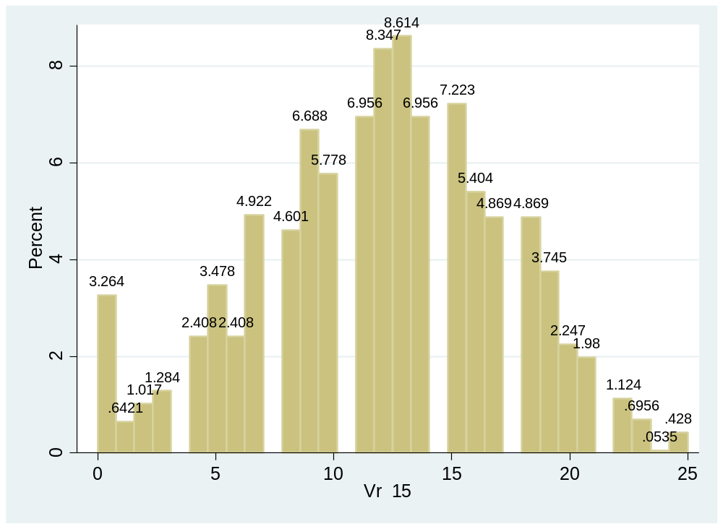
Variable | Obs Mean Std. Dev. Min Max
-------------+--------------------------------------------------------
Vr15 | 1869 11.9 5.1 0 25

Candidates fair average in this question.
(b) Why was the question answered poorly? Also provide specific examples, indicate common errors committed by learners in this question, and any misconceptions.
The following posed challenges to candiates:
Q 15.4.1 “reaksie in die toneelaanwysing”
Q 15.4.3 “waarom is verwyt ironies”
Q 15.7 “watter bevryding ervaar die karakters”
Q 15.10 ”funksie van die beletseltekens/ellips”
(c) Provide suggestions for improvement in relation to Teaching and Learning.
Thorough knowledge of content and terminology used.
(d) Describe any other specific observations relating to responses of learners and comments that are useful to teachers, subject advisors, teacher development etc.
Practice terminology used in previous exam papers and setting of questions.

QUESTION 16
(a) General comment on the performance of learners in the specific question. Was the question well answered or poorly answered?
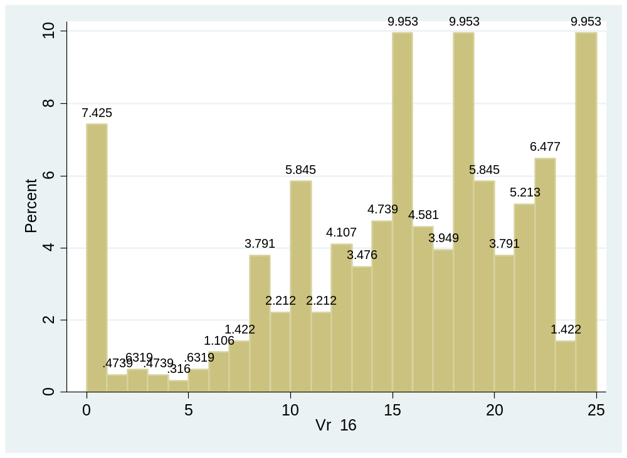
Variable | Obs Mean Std. Dev. Min Max
-------------+--------------------------------------------------------
Vr16 | 633 15.0 6.79 0 25

Question well answered; very good performance
(b) Why was the question answered poorly? Also provide specific examples, indicate common errors committed by learners in this question, and any misconceptions.
Candidates portrayed a thorough knowledge of the two male characters in this drama.
Some candidates however failed to link or referred to “Meisie se optrede aan die einde van die drama”.
(c) Provide suggestions for improvement in relation to Teaching and Learning.
Teaching of skills and knowledge is essential for construction of a good essay. Assure that candidates know all characters and their roles.
(d) Describe any other specific observations relating to responses of learners and comments that are useful to teachers, subject advisors, teacher development etc.
Ensure that ALL CANDIDATES grasp and understand the structure and construction of an essay with proper and appropriate arguments.

QUESTION 17
(a) General comment on the performance of learners in the specific question. Was the question well answered or poorly answered?
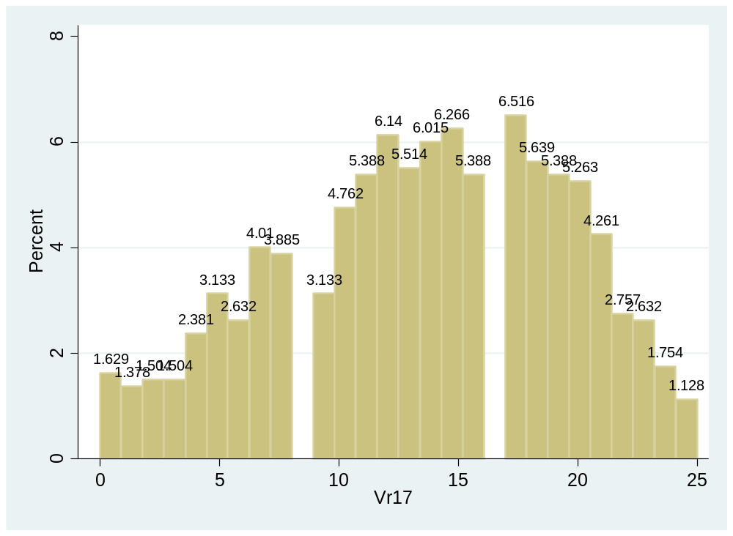
Variable | Obs Mean Std. Dev. Min Max
-------------+--------------------------------------------------------
Vr17 | 798 13.5 5.97 0 25

Relatively good performance in this question.
(b) Why was the question answered poorly? Also provide specific examples, indicate common errors committed by learners in this question, and any misconceptions.
The following questions were difficult:
Q 17.3 “redes waarom die verdwynings Miem se gesprek oorheers”
Q 17.4 “ Twee sake waaroor Konstabel nie volledig ingelig is nie”
Q 17.6 “ ironie “
Q 17.11 “Waarom is Meisie betower deur die sirkusmusiek”
Q 17.12.2 “sluit die titel by Meisie se onskuld aan?”
(c) Provide suggestions for improvement in relation to Teaching and Learning.
Require very good knowledge of content. Examination skills on how to interpret question and linking concepts within the question to give a proper response.
(d) Describe any other specific observations relating to responses of learners and comments that are useful to teachers, subject advisors, teacher development etc.
Candidates and teachers must read and discuss the genre/book in class! Teachers need to research and prepare for lessons; specifically, on any possible essay questions (especially within expected examination style for CAPS system).
The two (2) dramas relate to current social challenges in S.A.-society which can stimulate classroom conversation.
Another recommendation: search the Internet / Google where you can find thousands of resources on all genres or titles. Candidates are inclined to visual stimuli so it is recommended to make use of videos, PPT and all other electronic media which will improve interest first and ultimate teaching and learning.
Suggested Internet sites: WCED, Eastern Cape Education Department, DBE, Thutong, etc.

